Module 3:
Creating Python Programs
Jeremy Matthews
Colorado State University Global
CSC500– Principles of Programming
Dr. Douglas Mujeye
Due Date: 03/01/26

Part 1: Meal Purchase Calculator
Psuedocode
BEGIN
TRY
PROMPT user for food charge
STORE input as food_charge (float)

IF food_charge < 0 THEN
DISPLAY "Error: Food charge cannot be negative."
ELSE
SET tip = food_charge * 0.18
SET tax = food_charge * 0.07
SET total = food_charge + tip + tax

DISPLAY food_charge
DISPLAY tip
DISPLAY tax
DISPLAY total
END IF

CATCH ValueError
DISPLAY "Error: Please enter a valid number for the food charge."
END TRY
END

Source Code
try:
# Get the food charge from the user
food_charge = float(input("Enter the charge for the food: $"))

# Validate that the charge is not negative
if food_charge < 0:
print("Error: Food charge cannot be negative.")
else:
# Calculate tip and tax
tip = food_charge * 0.18
tax = food_charge * 0.07

# Calculate total
total = food_charge + tip + tax

# Display the results
print(f"Food Charge: ${food_charge:,.2f}")
print(f"Tip (18%): ${tip:,.2f}")
print(f"Sales Tax (7%): ${tax:,.2f}")
print(f"Total: ${total:,.2f}")

except ValueError:
print("Error: Please enter a valid number for the food charge.")

Part 2: Multiplication and Division
Pseudocode
BEGIN
TRY
PROMPT user for current time in hours (0-23)
STORE input as current_time (integer)

IF current_time < 0 OR current_time > 23 THEN
DISPLAY "Error: Current time must be between 0 and 23."
ELSE
PROMPT user for number of hours to wait
STORE input as hours_to_wait (integer)

IF hours_to_wait < 0 THEN
DISPLAY "Error: Hours to wait cannot be negative."
ELSE
SET alarm_time = (current_time + hours_to_wait) MOD 24
DISPLAY alarm_time
END IF

END IF

CATCH ValueError
DISPLAY "Error: Please enter a valid whole number."
END TRY
ENDSource Code
try:
# Get the current time and wait duration from the user
current_time = int(input("Enter the current time (0-23): "))

# Validate the current time is within the 24-hour range
if current_time < 0 or current_time > 23:
print("Error: Current time must be between 0 and 23.")
else:
hours_to_wait = int(input("Enter the number of hours to wait: "))

# Validate that hours to wait is not negative
if hours_to_wait < 0:
print("Error: Hours to wait cannot be negative.")
else:
# Calculate the alarm time using modulo to wrap around the 24-hour clock
alarm_time = (current_time + hours_to_wait) % 24

# Display the result
print(f"The alarm will go off at {alarm_time}:00 on a 24-hour clock.")

except ValueError:
print("Error: Please enter a valid whole number.")

Screenshots
Application Executing Program
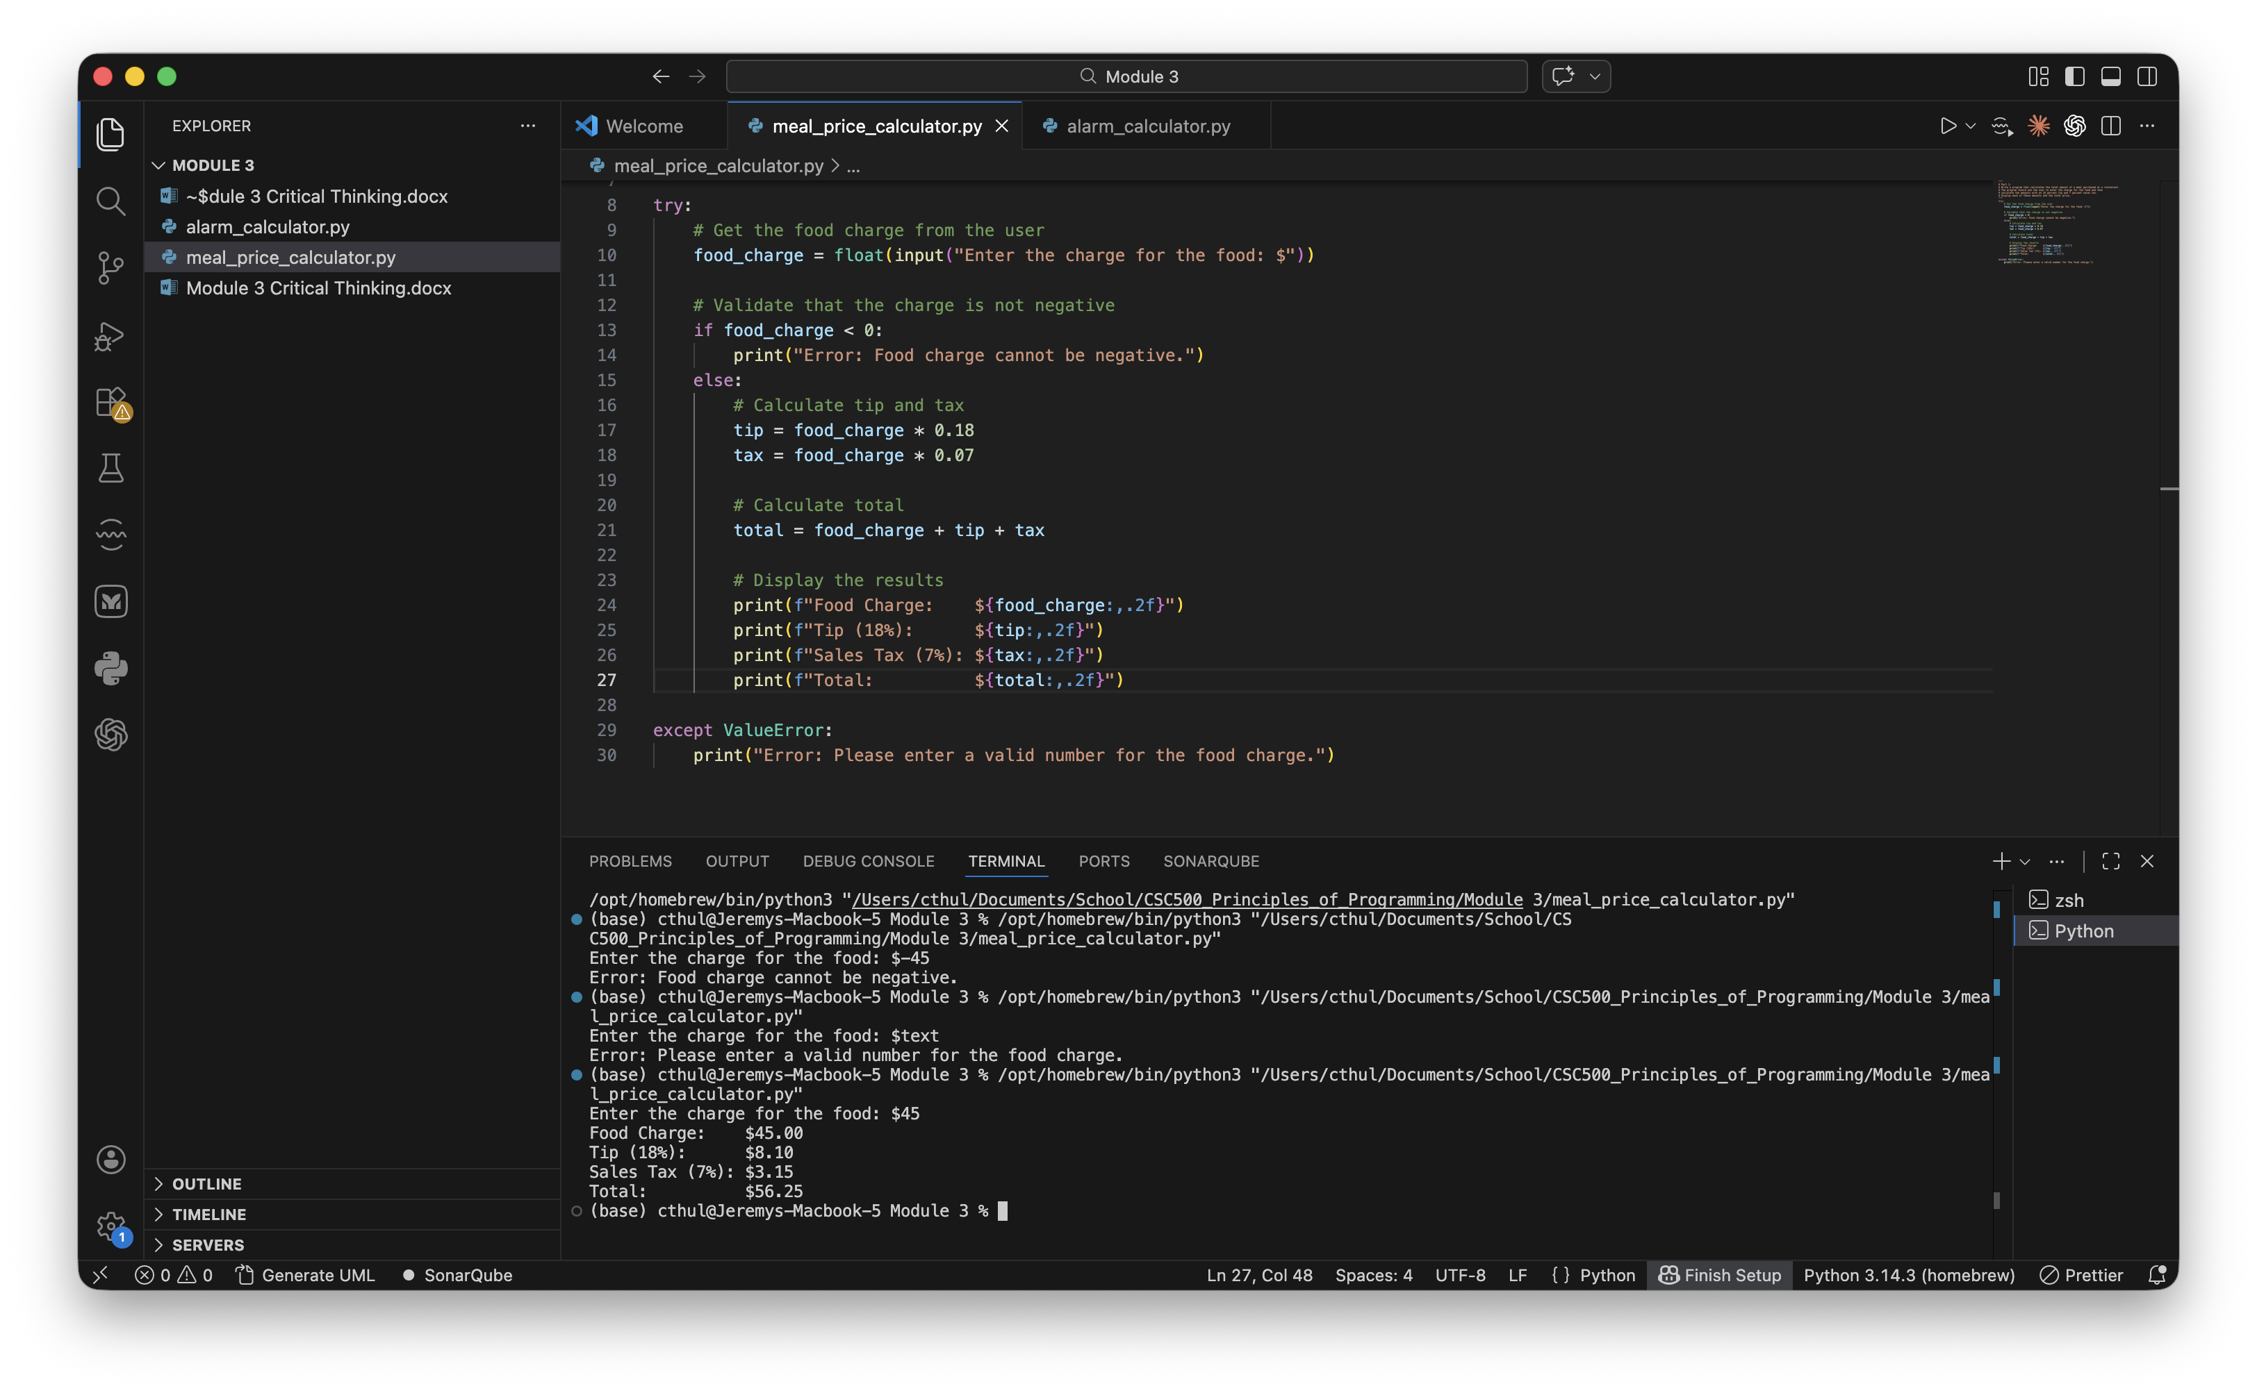
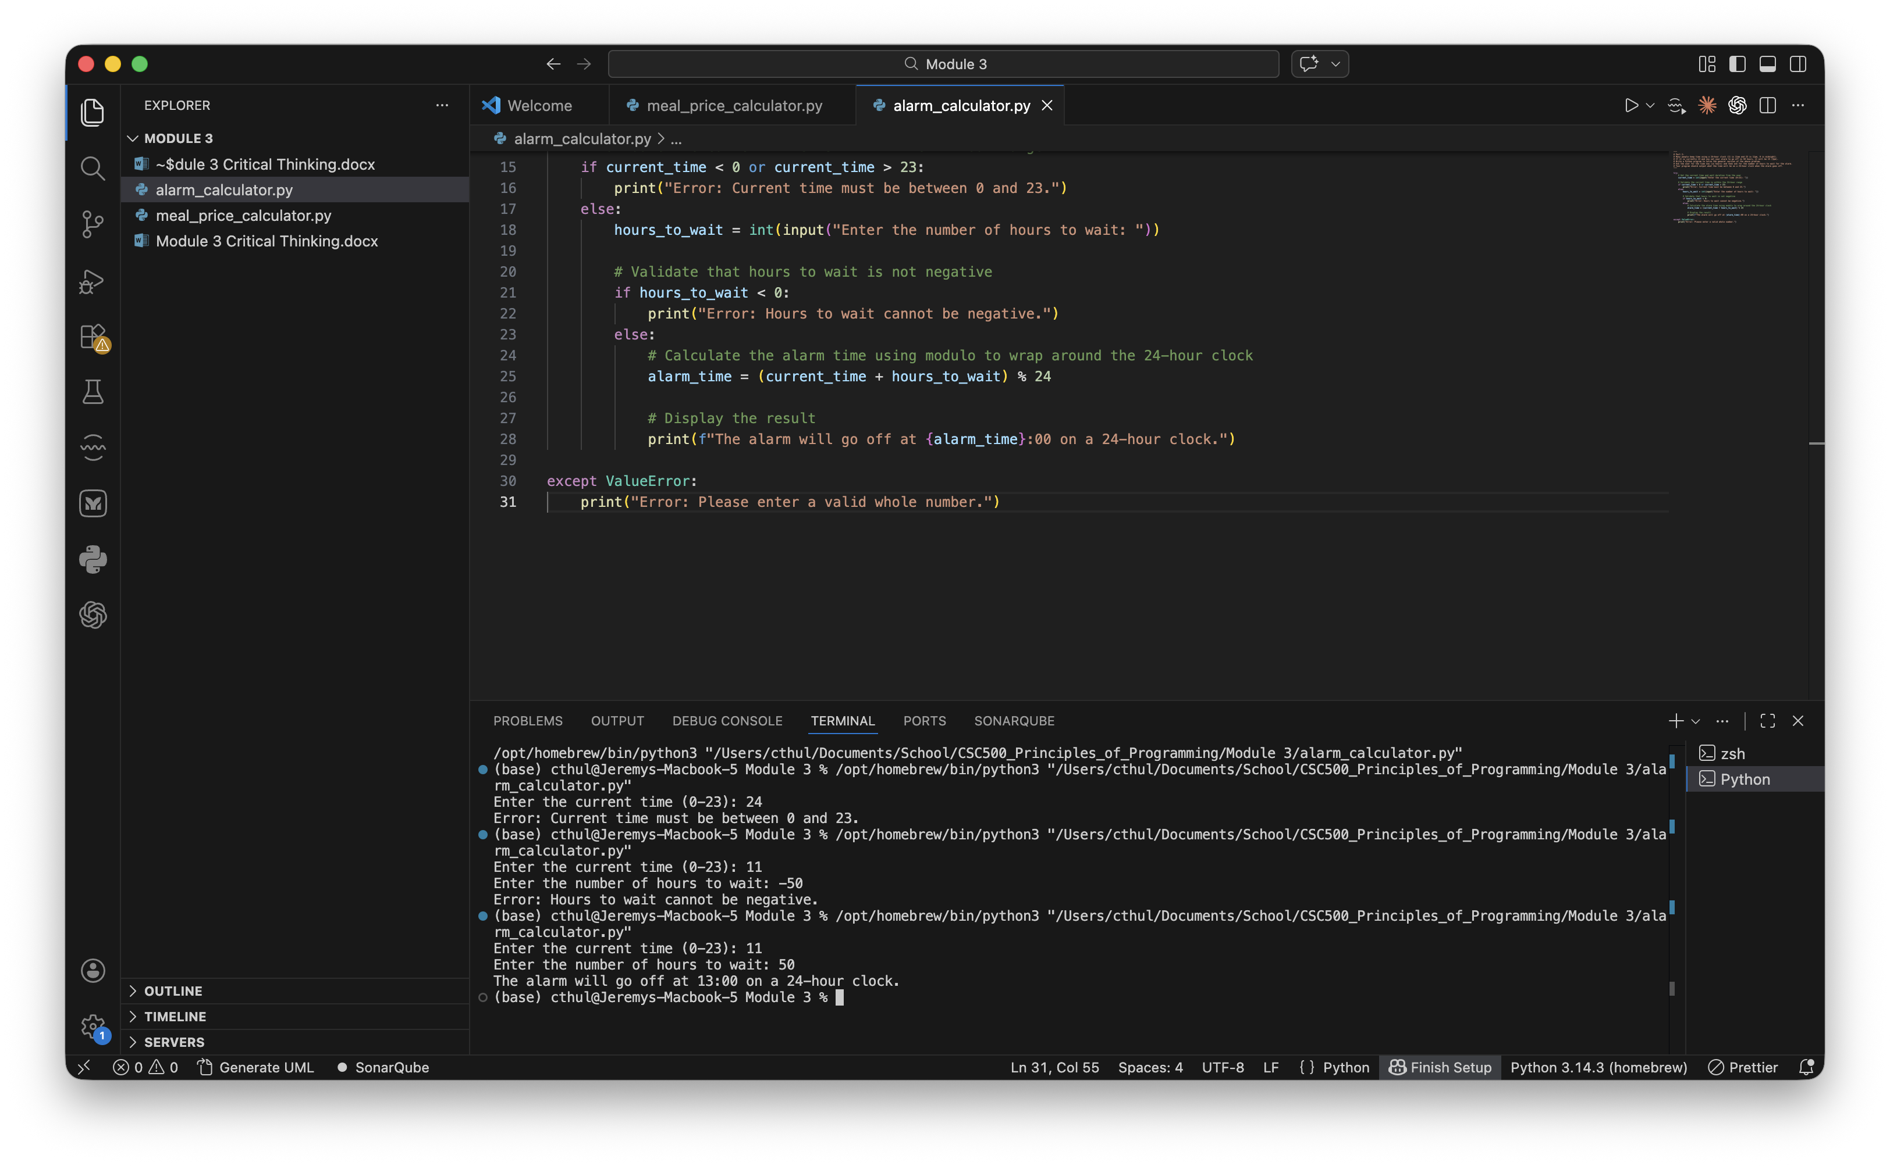
Results
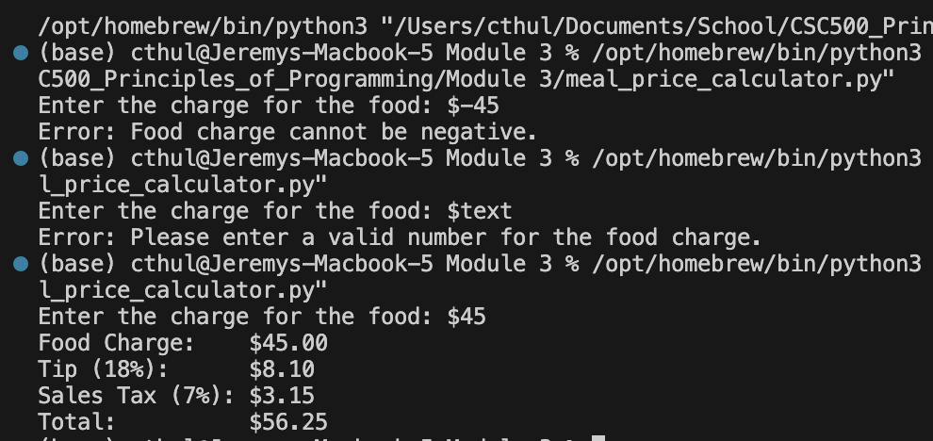
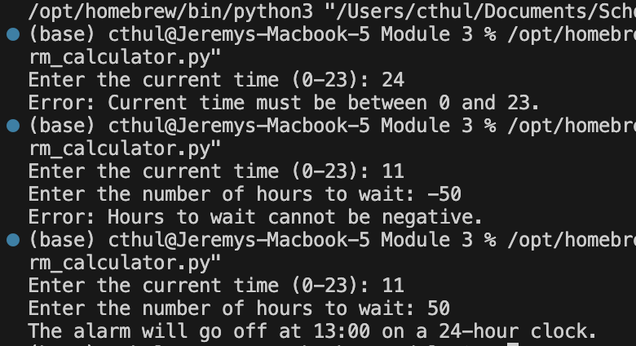
Github Repository
https://github.com/m9dful1/CSC500_Principles_of_Programming/tree/main/Module%201

